# SQL Assignment 2

**Given table is :-**

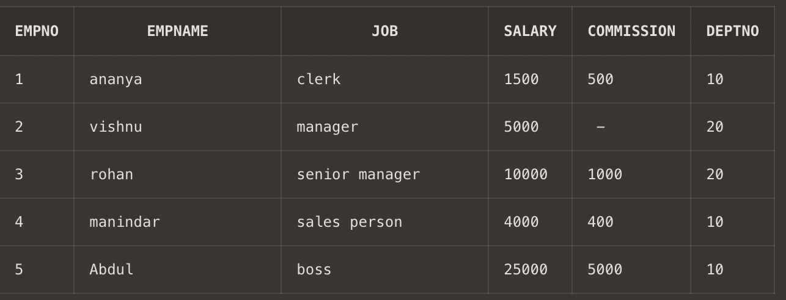

**Q1. Get employee no and employee name who works in dept no 10 ?**

**Ans1- select * from employee where DeptNo=10;**

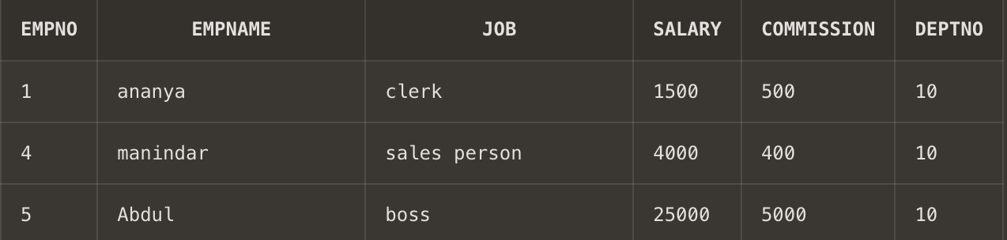

**Q2.** **Display the employee names of those clerks whose salary > 2000 ?**

**Ans2. select * from employee where salary>2000;**

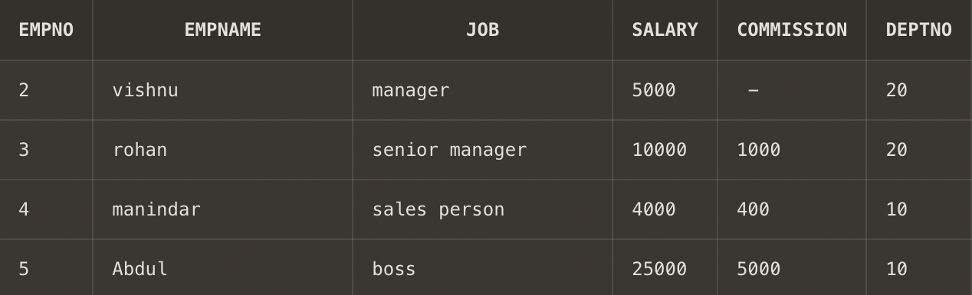

**Q3. Display name and job of Salesperson & Clerks ?**

**Ans3. select empname,job from employee where job='sales person' or job ='clerk';**

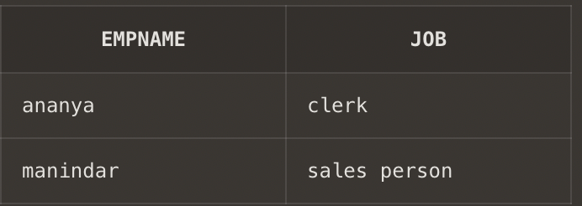

**Q4. Display all details of employees whose salary between 2000 and 3000 ?**

**Ans4. select * from employee where salary between 2000 and 3000;**

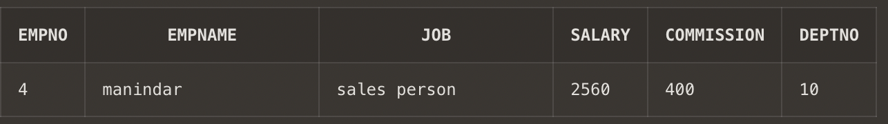

note- manindar’s salary column is updated here to get the desired answer;

**Q5. Display all details of employees whose dept no is 10 , 20 , or 30 ?**

**Ans5. select * from employee where deptno=10 or deptno=20 or deptno=30;**

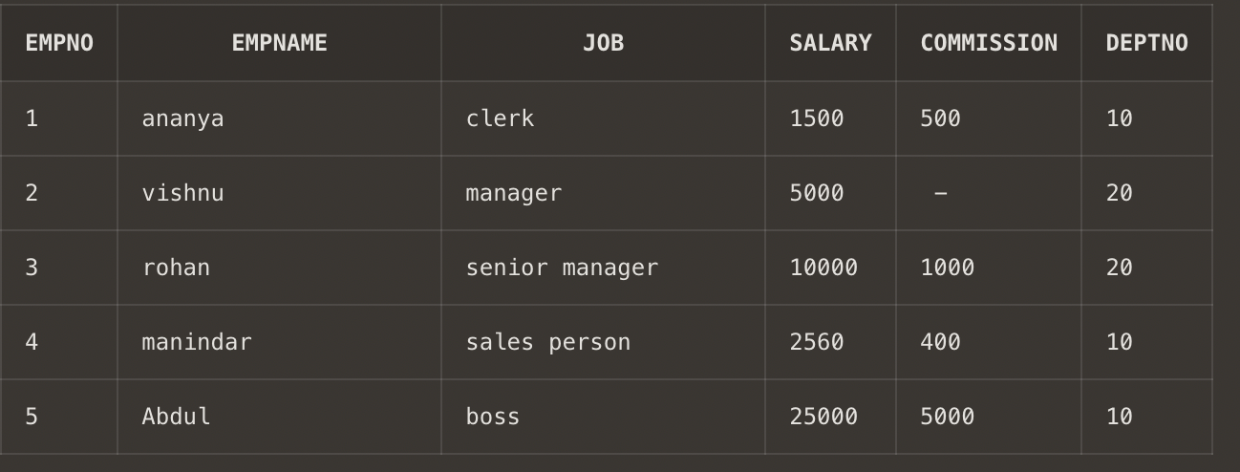

**Q6. Display name of those employees whose commission is NULL ?**

**Ans6. select * from employee where commission is null;**

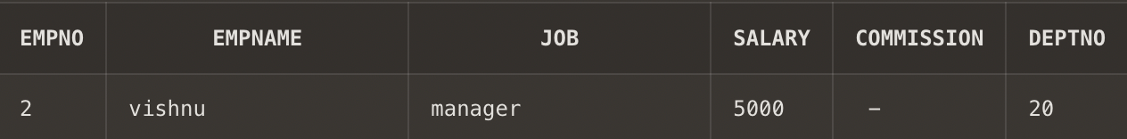

**Q7. Display dept no & salary in ascending order of dept no and with in each dept no salary should be in descending order ?**

**Ans7. select deptno,salary from employee order by deptno asc , salary desc;**

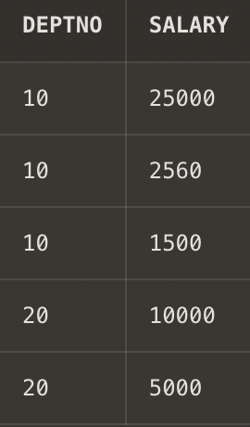

**Q8. Display name of employees having two ‘a’ or ‘A’ chars in the name ?**

**Ans8. select empname from employee where empname like '%a%a%';**

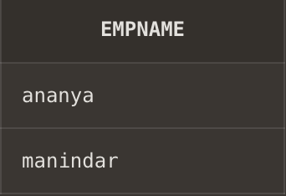

**Q9. Display the name of the employees whose second char is ‘b’ or ‘B’ ?**

**Ans9. select empname from employee where empname like '_b%';**

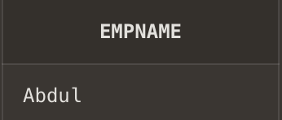

**Q10. Display the name of the employees whose first or last char is ‘a’ or ‘A’ ?**

**Ans10. select empname from employee where empname like 'a%'or empname like '%a' or empname like 'A%' or empname like '%A';**

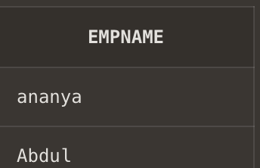

**Q11. Display maximum, minimum, average salary of deptno 10 employees.**

**Ans11. select max(salary) as MAXIMUM_SALARY, min(salary) as MINIMUM_SALARY ,avg(salary) as AVERAGE_SALARY from employee where deptno=10;**

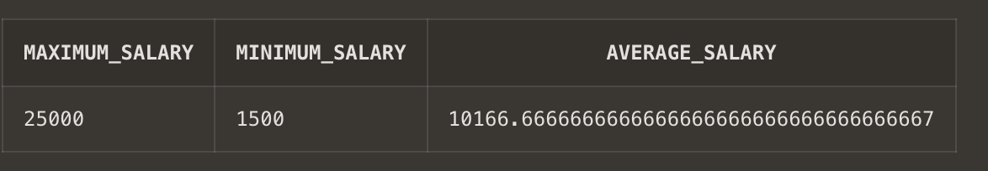

**Q12. Display total number of employees working in deptno 20.**

**Ans12. select count(empno) as TOTAL_EMPLOYEES from employee;**

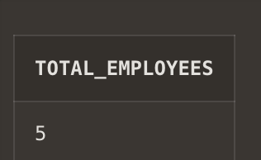

**Q13. Display total salary paid to clerks.**

**Ans13. select sum(salary) as TOTAL_SALARY from employee where job='clerk';**

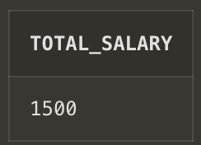

**Q14. Display system date.**

**Ans14. select to_date(sysdate) from dual;**

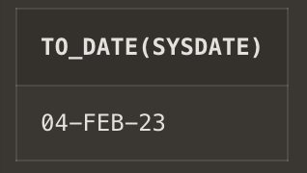

**Q15. Display the result of (12*12)/13.**

**Ans15. select (12*12)/13 as "MATHS QUESTION" from dual;**

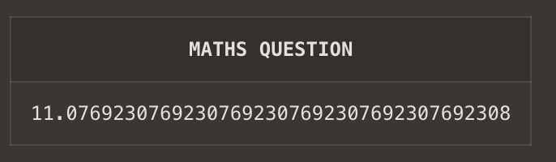

**Q16. Display info of ‘raj’ irrespective to the case in which the data is stored.**

**Ans16. select * from Emp where Ename='Raj';**

